How Franchisors Can Generate
More Quality Franchise Sales Leads . . . With Some Help From One of the World’s Largest Databases!

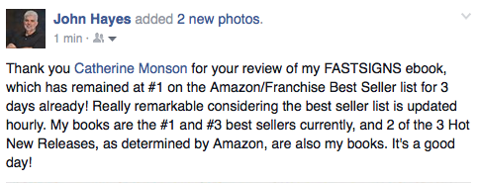

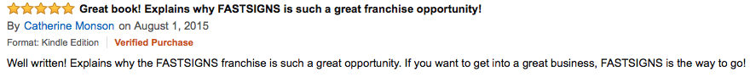

Catherine Monson is CEO of FASTSIGNS®

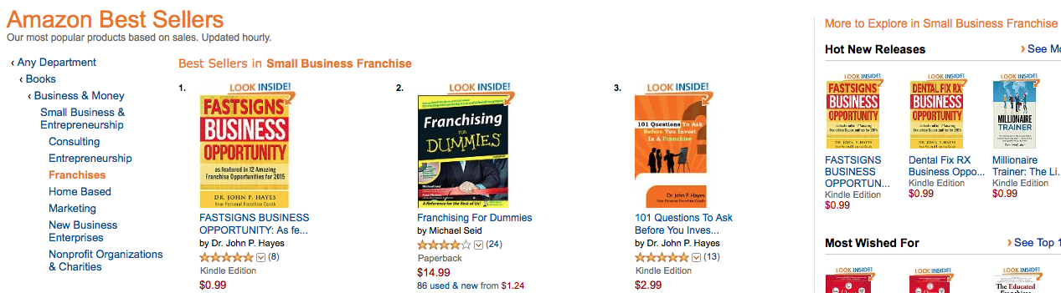

WHAT DID FASTSIGNS DO?

Literally within an hour of FASTSIGNS’ marketing team learning that Amazon had posted the FASTSIGNS Business Opportunity ebook, the team went to work to solicit reviews of the book. They asked members of their Home Office Team, members of their Franchise Sales Team, and members of their Franchise Network to go to Amazon.com, purchase the ebook (purposely priced at 99 cents to attract reviewers), and review it . . . once the ebook began selling, and readers posted reviews, the title moved into the #1 position on the Amazon Best Seller list for the Small Business Franchise category. As of this writing, the title has kept that position for 3 days – that’s extraordinary because the list is updated hourly!

Please note that ebooks are easily downloaded to any smart device. You do not need a Kindle Reader.

HOW DOES AMAZON’S DATABASE HELP?

A #1 Best Seller with more than just a few reviews will soon be identified by the Amazon algorithm and then Amazon will begin to help promote the book . . . keep in mind that Amazon is a gigantic database that attracts people in need of things – in this case, people who need information about franchise business opportunities. With Amazon’s help, FASTSIGNS is going to get more than a fair share of notice!

In the near future, Amazon will promote a 3-day free giveaway for the FASTSIGNS Business Opportunity ebook. . . that promotion will place hundreds, and perhaps more than a thousand, copies of the ebook into the smart devices of people who are considering the purchase of a franchise opportunity.

Because of a book’s credibility, books have historically out-marketed brochures, flyers, websites, free reports, etc. No one would expect a book to sell a franchise, but books generate genuine interest in franchise opportunities and produce qualified franchise sales leads.

2 August 2015

